Dependencies:

---------------------

spring-boot-starter-mail

Spring Web

Spring Boot dev tools

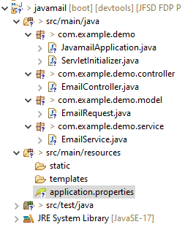

**App_Password from gmail account:**

Open Google Accounts -> signIn ->

Security Tab -> 2step Verification is Turn On ->

Search App Passwords -> Enter your gmail password to authenticate ->

Enter App name (Ex: job portal) press enter ->

you will get App_Password.

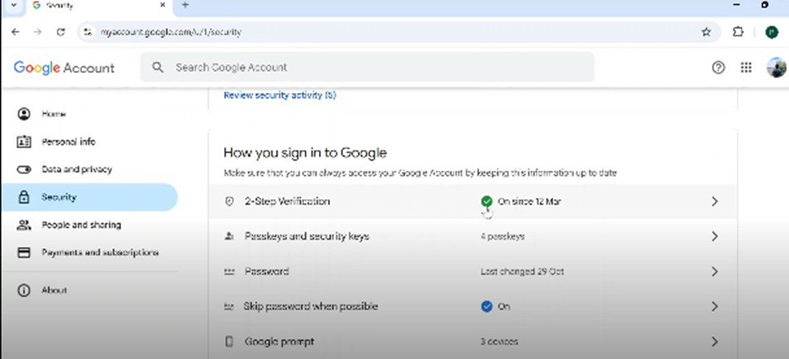

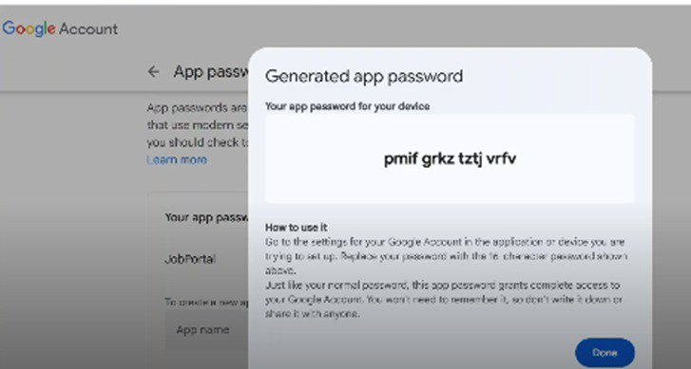

**Servlet Initializer.java**

package com.klu;

import org.springframework.boot.builder.SpringApplicationBuilder;

import org.springframework.boot.web.servlet.support.SpringBootServletInitializer;

public class ServletInitializer extends SpringBootServletInitializer {

@Override

protected SpringApplicationBuilder configure(SpringApplicationBuilder application) {

return application.sources(JavaSpringBootMailApplication.class);

}

}

**EmailController.java**

**package** com.klu.controller;

**import** org.springframework.beans.factory.annotation.Autowired;

**import** org.springframework.http.ResponseEntity;

**import** org.springframework.web.bind.annotation.CrossOrigin;

**import** org.springframework.web.bind.annotation.PostMapping;

**import** org.springframework.web.bind.annotation.RequestBody;

**import** org.springframework.web.bind.annotation.RestController;

**import** com.klu.model.EmailRequest;

**import** com.klu.service.EmailService;

@RestController

@CrossOrigin("*")

**public** **class** EmailController {

@Autowired

**private** EmailService emailService;

@PostMapping("/send-email")

**public** ResponseEntity<String> sendEmail(@RequestBody EmailRequest emailRequest) {

emailService.sendEmail(emailRequest.getTo(), emailRequest.getSubject(), emailRequest.getBody());

**return** ResponseEntity.*ok*("Email sent successfully!");

}

}

**EmailRequest.java**

**package** com.example.demo.model;

**public** **class** EmailRequest {

**private** String to;

**private** String subject;

**private** String body;

**public** String getTo() {

**return** to;

}

**public** String getSubject() {

**return** subject;

}

**public** String getBody() {

**return** body;

}

**public** **void** setTo(String to) {

**this**.to = to;

}

**public** **void** setSubject(String subject) {

**this**.subject = subject;

}

**public** **void** setBody(String body) {

**this**.body = body;

}

}

**EmailService.java**

**package** com.klu.service;

**import** org.springframework.beans.factory.annotation.Autowired;

**import** org.springframework.mail.SimpleMailMessage;

**import** org.springframework.mail.javamail.JavaMailSender;

**import** org.springframework.stereotype.Service;

@Service

**public** **class** EmailService {

@Autowired

**private** JavaMailSender mailSender;

**public** **void** sendEmail(String to, String subject, String body) {

SimpleMailMessage message = **new** SimpleMailMessage();

message.setTo(to);

message.setSubject(subject);

message.setText(body);

message.setFrom("kodavali.lakshmi@gmail.com"); // Optional

mailSender.send(message);

}

}

**Application.properties**

spring.application.name=JavaSpringBootMail

spring.mail.host=smtp.gmail.com

spring.mail.port=587

spring.mail.username=kodavali.lakshmi@gmail.com

spring.mail.password=ygel zxuc uecc lxow

spring.mail.protocol=smtp

spring.mail.properties.mail.smtp.auth=true

spring.mail.properties.mail.smtp.starttls.enable=true

**OUTPUT**

